Hope Anchor
for September 2023


211 Elton Adelphia Road
Freehold NJ 07728

Growing in Faith, Love and Service
www.youtube.com/hopefreehold www.facebook.com/hopefreehold
www.instagram.com/hopefreehold  www.hopefreehold.org

Welcome to Our New Staff Member!

It’s my pleasure to announce to the Hope Family that the Congregation Council has hired a new staff member. Well sort of…

What I mean by this is that, yes, we have a new member on our Hope Lutheran Church Staff. But he’s not exactly new, however. Let me explain.

Over the past year, we have been considering a new position in the area of “Faith Formation” for the congregation. Chelle Huth, who leads the Faith Formation Certificate Program for United Lutheran Seminary, advised and guided us through the process. We were originally envisioning it as a “Youth and Family Ministry” position. However, she suggested that we refer to it as a “Director of Faith Formation” instead, because this person would coordinate faith development opportunities for people of all ages. Not just children and youth. Although children and youth would still be a significant focus of his or her efforts.

From Council, we recruited a Faith Formation team to develop a job description and conduct the search process. I joined Sarah Kozak, Jess Somodi, Matt Sprunger, and Kate Raguseo on this team. Through a series of meetings, including a Zoom conversation with Chelle, we developed
the job description and requirements, outlined the search process we would follow, and then posted the job. (Special thanks to Sarah for being the lead writer on this!)

We then advertised the job with the ELCA Youth Ministry Network, our own New Jersey Synod of the ELCA, the Greater Freehold Clergy Association, and also on the job search site Indeed. In response, we received a total of six applications. Four of the applicants, however, did not have the required skills or experience. So we thanked them for their interest, but elected not
to interview them. The remaining two candidates, though, were then brought in for a first interview.

After interviewing one of the two candidates, we elected not to offer a second interview because the individual, while having an impressive resume, did not appear to be a good fit for the position or for our congregation.

The second candidate was offered a second interview with two of the members of the Executive Committee of Council, Bill Unger and Mike Dellar Rosa. With their endorsement, the candidate then also had a third interview, which consisted of a Sunday morning children’s sermon. Following this, a new job description was developed (for reasons about to be made clear) and a compensation package was finalized. And, at our most recent meeting on August 21, the Hope Council voted unanimously to hire JOSH STAUDINGER as Hope’s new “Director of Faith Formation and Music Ministry.”

Now you know why I said we have a “new” staff member who’s not exactly new!
Josh, of course, has been an integral part of the Hope congregation and ministry for several years now. He is universally liked and respected. And we believe that he will do an outstanding job in his newly expanded position.

As his job title indicates, Josh will continue to direct the music ministry of the congregation. (Not to mention communications and technology as well!)

But now he will also work with me and others (including Jess Somodi who coordinates our Sunday school) in developing faith formation efforts (i.e. educational, fellowship and service opportunities) for the entire congregation. Again, not just for children and youth.
Therefore, the original job description had to be reworked slightly in order to accommodate and account for this dual role. But what we were finally able to come up with, and which Josh accepted, promises to be an exciting addition to our staff and to Hope’s ministry.

So please join me in welcoming Josh to his new position! And be on the lookout for new opportunities and ventures in the area of faith formation in the weeks and months to come.

Pastor Ed



Starting Sunday, September 10
9am – Traditional Service
10am – Sunday School
11am – Contemporary Service



Sunday School will begin again Sunday, September 10 running the hour between the
Worship services again 10am – 11am
Here is the Registration Link -
Hope Lutheran Church Sunday School Registration (google.com)
We will also KICK OFF with our Annual
Backpack Blessing at the 11am Service


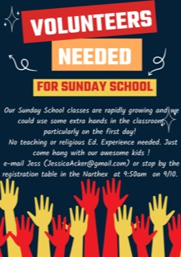

Come volunteer in the most rewarding way possible!
Service hours can be given upon request!!


Our Next meeting will be:
Sunday, September 17 between the services in the Counseling Room and we will be discussing….



Featured Items:
Pasta, Oatmeal, Canned Chicken, Dried Beans

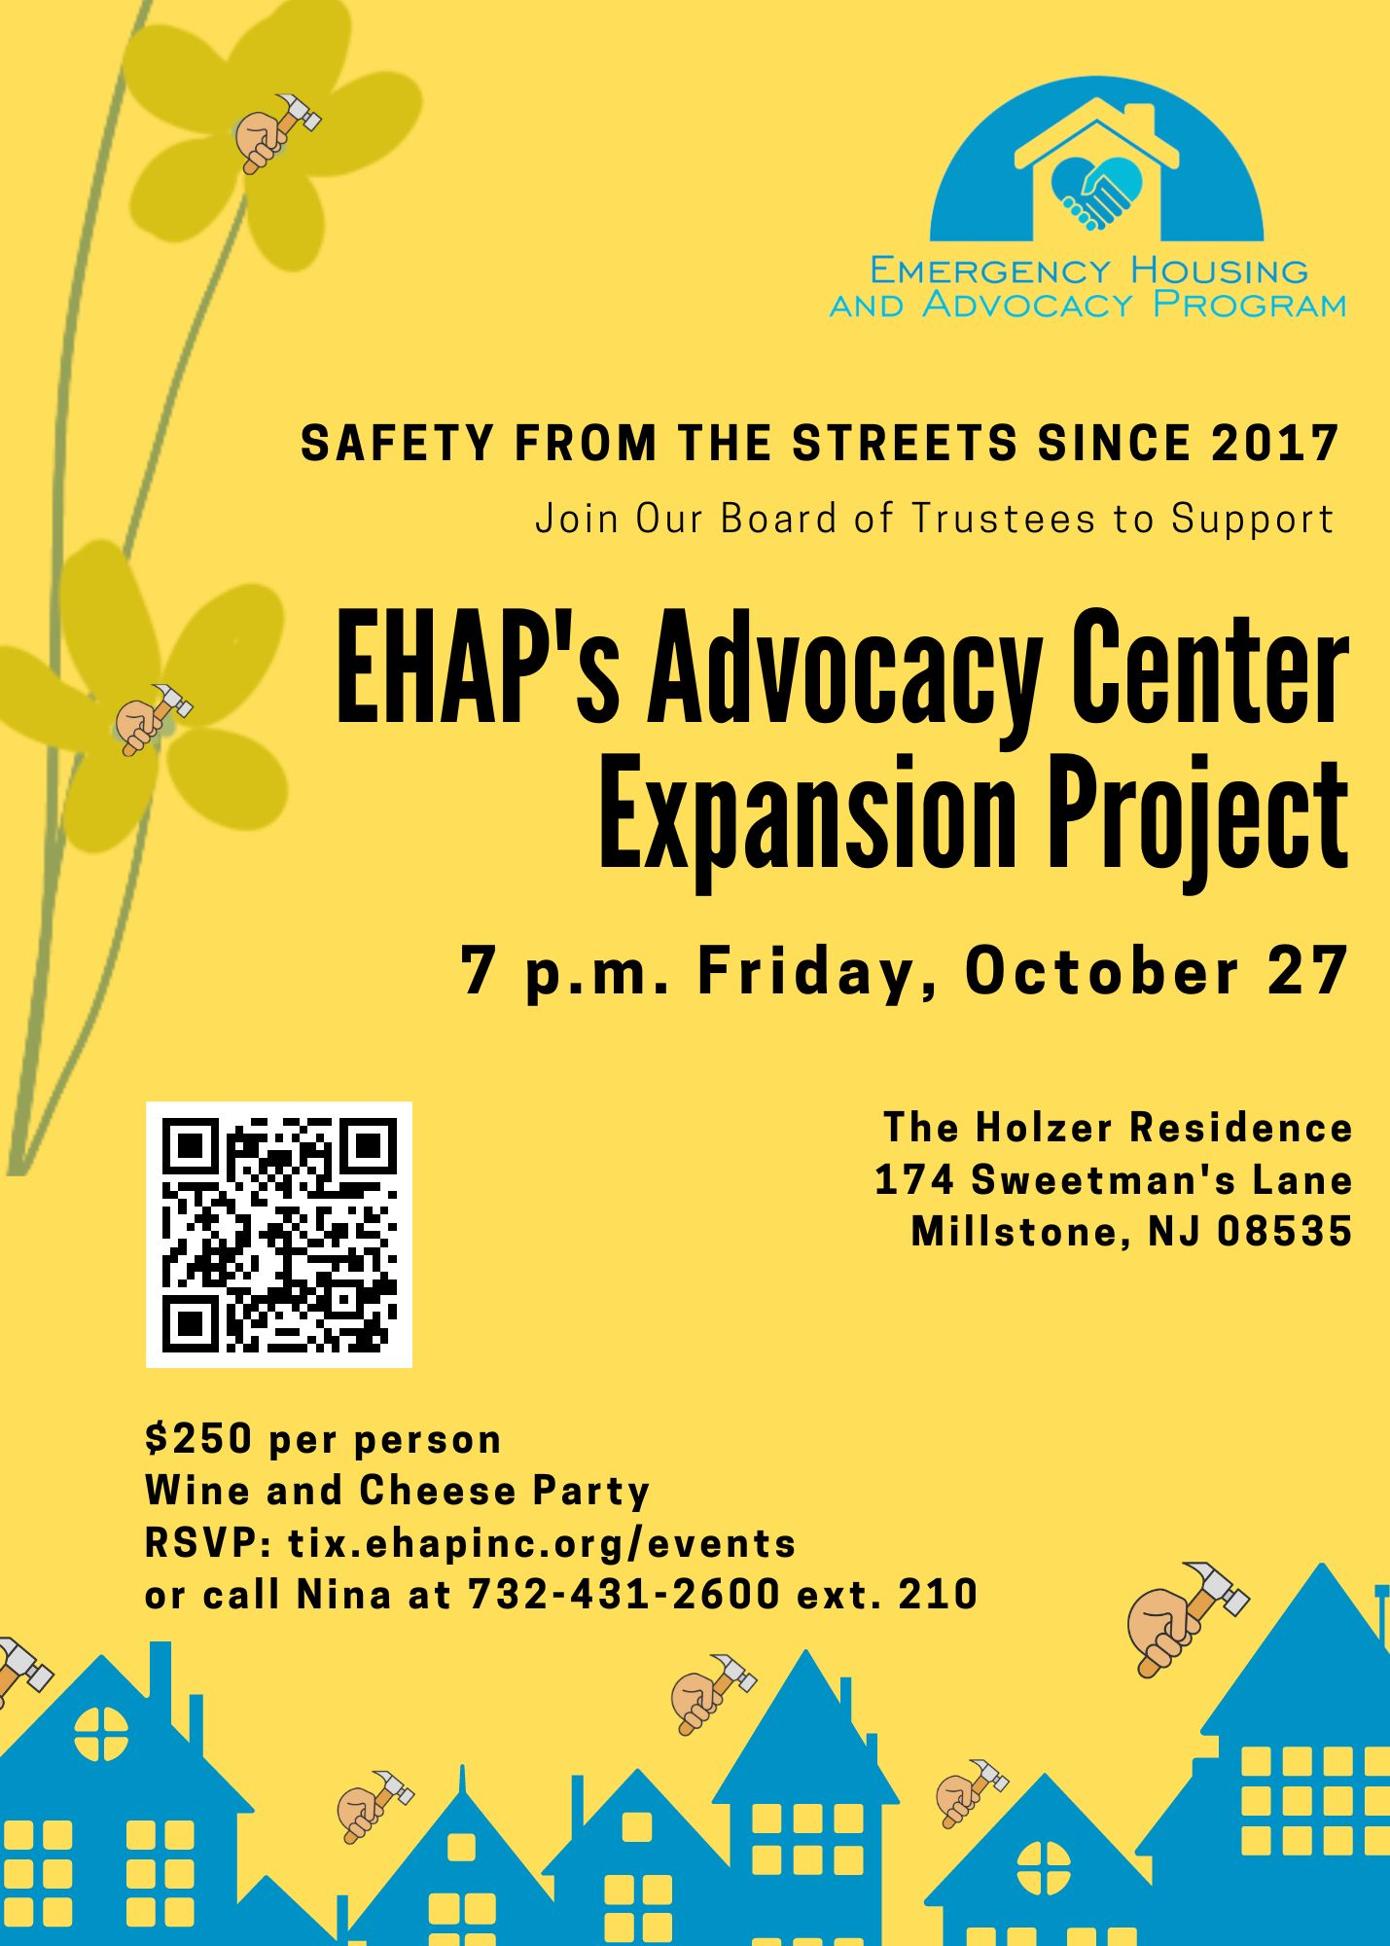


Our next round of Outreach Meal Hostings are:
Friday, December 8, 2023
Friday, January 26, 2024
Friday, April 26, 2024

Hope Lutheran Church Council
Minutes July 17, 2023

Meeting was opened at 7:10 pm with the following council member present: Deb Bill Mike Sarah, Sue, Pastor, Matt M, Dave, Matt S, Brian, Absent: Michele, Pat, Jess, Steve
Mike submitted a revision to the June Congregational Minutes amended. Copy of revision was received. Bill made a motion to accept revised minutes seconded by Mike. Motion carried unanimously.
Carla Ray Maxwell & Christin Thorpe of Generis were present at our meeting to explain how their fundraising works:
Traditional methods work – however, when the campaign is over 90% of members return to what they were giving before campaign.
One Fund is a method which they tell us that 90% of members continue giving the same amount even after two years. This method creates teams at four distinct levels (core, pace setters, leaders, volunteers) that would be involved with educating small groups of the membership about what this whole campaign is about. The three basic steps of the One Fund are:
Preparation (proposed Jan./Feb.) educate teams.
Quiet (proposed Feb./March) educate small groups.
Public (proposed March/April) bring to the congregation.
By the time we would get to the public portion of this program they stated that 80% of the congregation is usually already committed to giving more for the campaign.
They also stated that they were working with Judy to get the school families involved in this campaign also.

Treasurer
Cheryl is having issues with Citizen Bank online banking. Mike has been looking to changing banks since bought out the previous bank. He suggested that we need to change banks. TD bank is close and stable with noticeably clear online banking website. This would need council to approve and temporarily move some of our money from Mission Investment so that there is enough in both the old and new operating account to cover bills during transition period. Sue made a motion to change operating account to TD bank and move necessary monies to accommodate this. This would include the following individuals approved to be check signers and administrator: John Drager, Administrator & Signer – Michael Della Rosa, Signer – William Unger, Signer – Pat Fensham, Signer. These individuals are authorized to act on behalf of the congregation council in conducting banking activities at TD Bank. This was seconded by Dave. Motion carried unanimously.
Mike will be proposing to change the Fiscal year to the Finance committee at the 7/24 meeting. We need to have it run from July thru June to make the numbers more accurate so that the school will know their budget needs. At this time, our budget runs from January to December. When Finance approves, council will need to have an electronic vote to make this change. Since this needs to be done immediately, (so they can prepare budgets) we will have an election vote on this change.
Faith Formation: Sarah reported that there have been six applicants – four of which were not really qualified. Two candidates will be interviewed. Their third interview will be in person at a Sunday Service.
Architectural Team: Bill is trying to schedule a meeting with the architects but there has been some illness issues causing a delay. He will call again this week to schedule a meeting with all those involved.
Sarah has accepted the position of Vice President.
Dave made a motion to adjourn the meeting seconded by Matt M. Pastor closed the meeting with a pray.
Respectfully submitted,
Deb Crawford
Congregation Council Meeting - August 21st

Those present were as follows: Bill, Jess, Sarah, Matt M, Pastor Ed, Michelle, Pat, Sue, Dave, Mike. Absent were Matt S, Deb Crawford, Steve Weiss

Pastor began the meeting with a prayer at 7:05.

Approval of Minutes: Motion from Bill to accept minutes written by Deb 7/17, second from Pat. Motion carried.
Council meeting minutes of July 17th, 2023.

Treasurer’s Report: Mike Della Rosa presented written report

Pastor’s Report: Pastor Kropa presented a written report.
- See Old Business for Director of Faith Formation and Music discussion

Old Business: Status / Updates (if available).
Updates: Kellenyi/Johnson/Wagner architectural team. Eric and Rich came and shared some preliminary plans with the council.
- Option 1 - multipurpose room closer to parking lot and entrance.
- Option 2- longer building with multi at the end

“Director of Faith Formation and Music.” Job updated job description and compensation package.
- Recommendation for hire is Josh Staudinger. Josh has agreed to the recently updated contract.
- Bill makes a motion to hire Josh as the Director of Faith Formation and Music. Dave second. Motion carried.

Generis update. “Generosity Initiative” proposal.
- Generis Strategy Report and Planning Session to Accelerated Giving
  - Council will review this packet to discuss next month, potentially asking the congregation in November.
- Generis Coaching Plan
  - Originally $10,000 for 10 sessions in 5 months. (discount to $9,800)
  - Could do 8 sessions for $8,000, Oct-January.
  - Pastor makes a motion to engage in a 4 month coaching plan for $8,000 (taken from the contingency fund), starting in October. Second by Michelle. Motion carried.

New Business:
2024 budget discussions. Projected 8-month spending plan (Jan-Aug 2024).
- Postponed for September meeting. Finance committee meeting on 8/23

Emergency Housing. Commitment for 23-24.
Next Zoom meeting scheduled for September. Details have not been finalized for the upcoming season, so we will hold off on signing the commitment letter. Prior to signing, we would like to gather support from the congregation to make sure we can support the commitment.

Bill makes a motion to donate $5,000 to Lutheran disaster response in Maui, coming from the undesignated benevolence fund. Second Jess. Motion carried.

Adjournment - 9 pm Pastor closed the meeting with prayer.

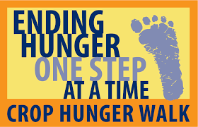
Sunday, October 22 @ 130pm
Freehold CROP Hunger Walk

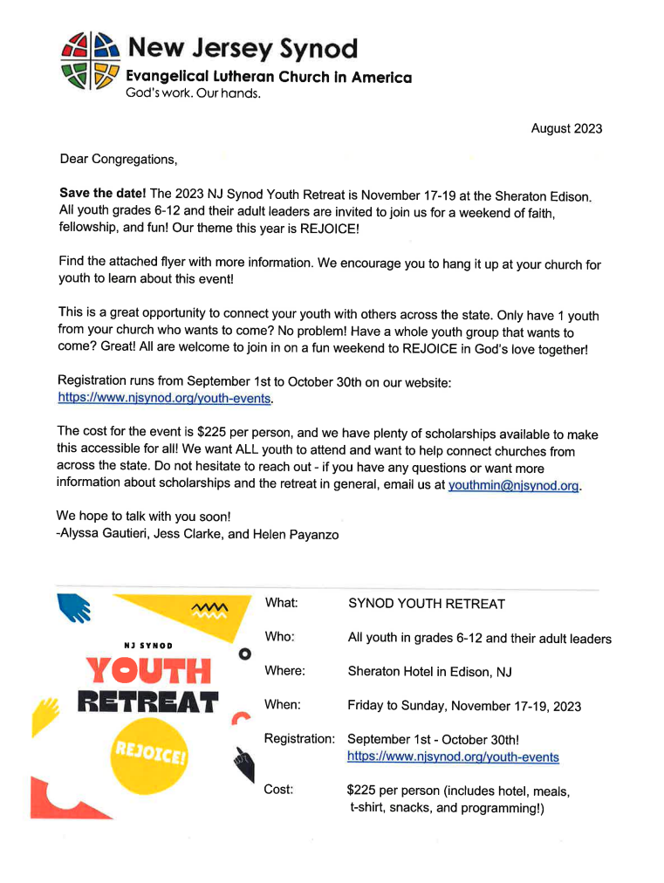

COMMUNICATING & COMMUNICATIONS

From time to time there is feedback received that leads us to believe there may be better opportunities / facilities to communicate with the Congregation. This was also raised at the recent June Congregation meeting where a few members mentioned we could communicate better.
Currently we use email programs and send the Weekly Update, the monthly Anchor and during the month several other email communications. These email addresses are received from you as we update the Hope directory yearly. We also have our website, Facebook, and Instagram messaging. Several members choose to receive their communications via USPS, if that is your preference, please let Cheryl know!! While attending services there are also other printed communications made available in the Narthex that provide valuable information and programs at Hope.
So, the question I am asking is what other methods, styles or vehicles of communication are you looking for?
This will become even more important as we look to developing focus groups to assist the Congregation when we have data received from the engineering firm on exactly what facility changes are being considered. Your voice and interactions will be critical to our continued success.

PLEASE IF YOU HAVE IDEAS OR SUGGESTIONS ON COMMUNICATING SHARE THAT WITH CHERYL, JOSH, PASTOR, OR A MEMBER OF YOUR CHURCH COUNCIL.

Thanks,
Bill for the Congregation Council

VOLUNTEERING:
GOOD FOR YOU AND GOOD FOR OUR COMMUNITY

Volunteerism is good for the Hope community because it is an investment in our Congregation and all the ministries that Hope Lutheran Church participates in. Another direct benefit also allows YOU to directly connect with others also helping in the Hope community. We have many programs that need your assistance.
For many years, we did an annual survey called the “Time and Talents”. We have addressed a 2023 version of the Time and Talents and we feel this is an excellent vehicle to get you to pick your “talent” and volunteer at Hope.
Volunteering builds self-confidence and self-esteem. Doing good for others and the community helps to create a natural sense of accomplishment. And working as a volunteer can also give you a sense of pride and identity, helping to boost your self-confidence further by taking you out of your natural comfort zone and environment.
This experience may also make you want to get involved with other aspects of your community, such as advocating for programs you believe are important. It also helps you meet new friends.

Top Ten Reasons to Volunteer

- It’s good for you. Volunteering provides physical and mental rewards. It reduces stress. Experts report that when you focus on someone other than yourself, it interrupts usual tension-producing patterns. Makes your healthier; moods and emotions, like optimism, joy, and control over one’s fate, strengthen the immune system.
- It saves resources. Volunteering provides valuable community services so more money can be spent on local improvements.
- Volunteers gain professional experience. You can test out a career.
- It brings people together. As volunteer, you assist in uniting people from diverse backgrounds to work toward a common goal building camaraderie and teamwork.
- It promotes personal growth and self-esteem. Understanding community needs helps foster empathy and self-efficacy.
- Volunteering strengthens your community. As a volunteer you help: support families (daycare and eldercare); improve schools (tutoring, literacy); support youth (mentoring and after-school programs) and beautify the community (beach and park cleanups).
- You learn a lot. Volunteers learn things like these. Self: volunteers discover hidden talents that may change your view on your self-worth. Government: through working with local non-profit agencies, volunteers learn about the functions and operation of our government.
Community: volunteers gain knowledge of local resources available to solve community needs.
- You get a chance to give back. People like to support community resources that they use themselves or that benefit people they care about.
- Volunteering encourages civic responsibility. Community service and volunteerism are an investment in our community and the people who live in it.
- You make a difference. Every person counts!

Hope Lutheran Church Time and Abilities Form 2023
YOUR NAME ___________________________________

OUTREACH: WORSHIP: Committee ___
Committee ___ Usher 900am 1100am
Contact Calls ___ Summer 930am
New Member Sponsor ___ Assist 900am 1100am
Shut in Visits ___ Summer 930am
Transportation ___ Altar Guild ___
EDUCATION: Choir ___
Sunday School Teacher ___ Praise Band ___
Sunday School Helper ___ Instrumental/Soloist ___
VBS Teacher/Helper ___ Childrens’ Message ___
Catechism Teacher/Helper ___ Puppeteer/Hope Homily ___
Catechism Sponsor ___
FELLOWSHIP: SUPPORT:
Committee ___ Committee ___
Youth Group Helper ___ Offering Counter ___
Event Planner ___ Stewardship ___
Women of Hope ___ Finance ___
Gathering Of Men ___
MAINTENANCE: SOCIAL CONCERNS:
Committee ___ Committee ___
Carpenter ___ Open Door ___
Electrical ___ Emergency Housing ___
Plumbing ___ Outreach Meals ___
Painting ___
Gardening ___ ADMINISTRATION:
Repairs ___ Congregation Council ___
Work Day Volunteer ___


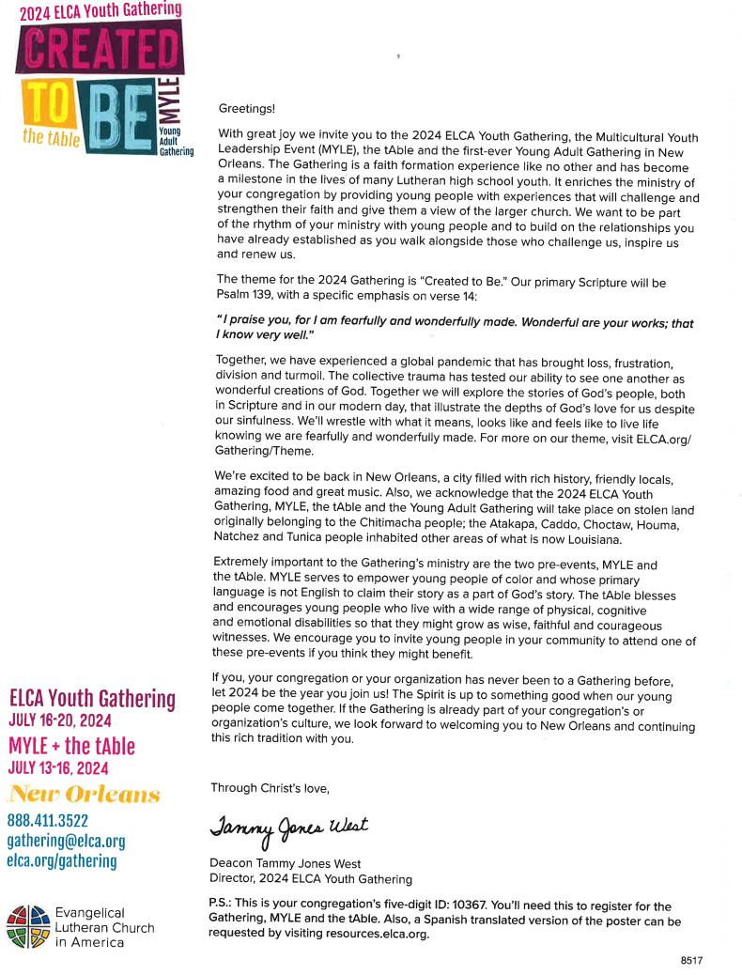

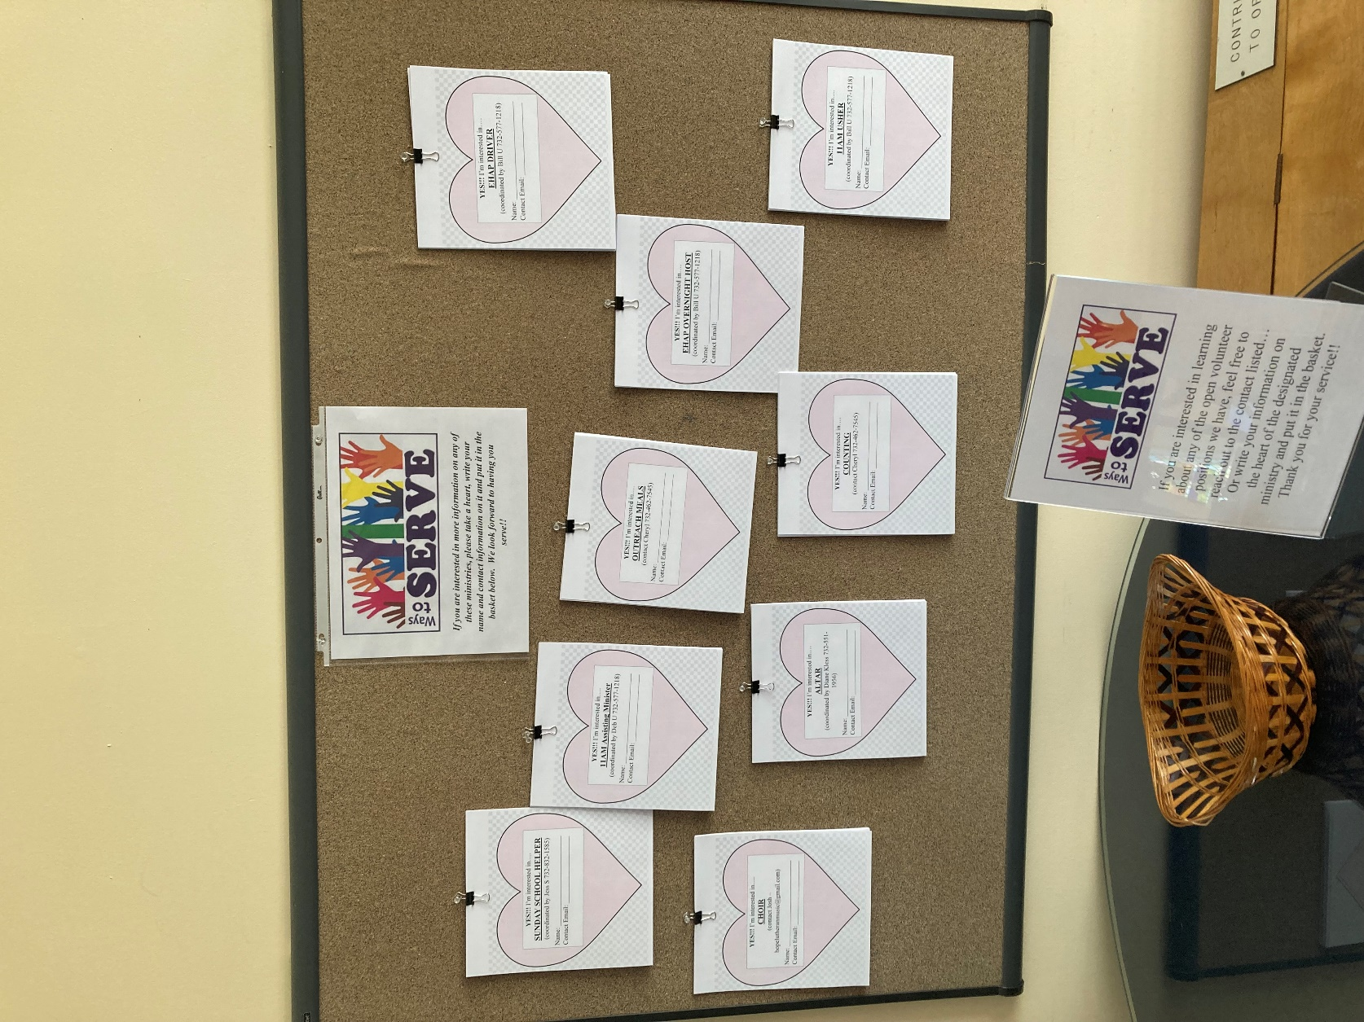

Come visit our Welcome Area upon entering the Church and visit to see where we need volunteer the most! If anyone is looking for service hours, I can be contacted at anytime, I always have something that can be done!!
Cheryl 732-462-7545
hopelutheran17@gmail.com
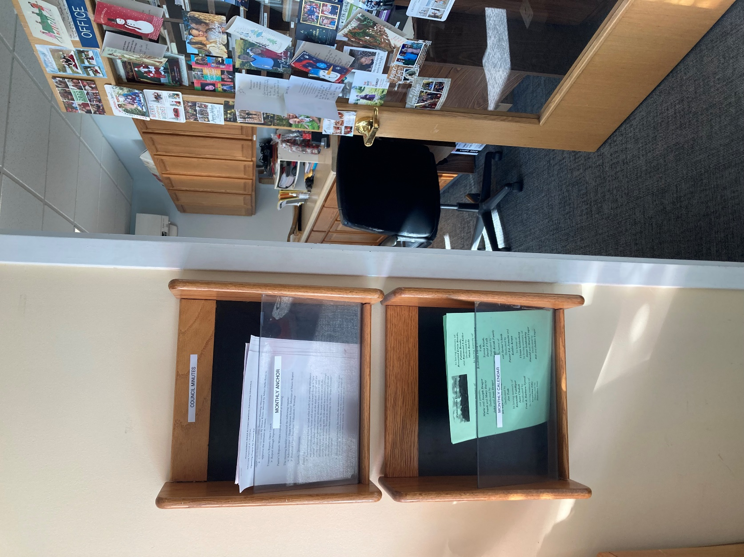
I noticed people have not been taking the monthly Anchor and Calendars I keep available outside of the office! I just wanted to point out that this is where they are in the beginning of the month and until they run out, along with any Council/Commission minutes that area available. Please help yourselves!!!


Counters are back!!!!!!
We are training and transitioning back to counting each Sunday after the second service.
PLEASE reach out if you are interested in learning to count and help us out!!! Once we get enough “teams” trained, the commitment will be no more than once a month for maybe 20-30 minutes.


The Women of Hope will be taking a break for the summer!
Stay tuned for when they get started again come September 2023!!
We invite all women members of Hope to attend. Come when you can! Stay as long as you like. Please let one of us know that you will attend by calling or emailing one of the members below.

Wanda Nebiolo, 732 267-1508 wwandygal@aol.com
Janice Seifert, 732 364-7196 janeseifer6@yahoo.com
Joan Drager, 732 431-1077 joandrager@verizon.net



The Gathering of Men Hope will be taking a break for the summer!
Next meeting will be
Saturday, September 9 @ 9AM



July Donations
Member Envelopes: $ 10975
Online Giving: $ 2641.11

August Donations
Member Envelopes: $ 6610
Online Giving: $ 3463.19

HOPE FAMILY PRAYER LIST

HCS Family, the Murphy’s could use prayers for
their father/grandfather who was recently diagnosed with
pancreatic cancer and is beginning treatment immediately,
Vincent Demonte;
Timmy Mariano has passed on to Life Eternal, many prayers
during their time of grief…

Wayne Kless’ sister, Jacqueline White; Sharon Moffitt; Justine Brozyna, friend of the Corn Family; Kuehn Family Friend, Deena Harmon; Deloris Laub; Laura Becker; Bonnie Palamara; Pastor’s former parishioner, Eric Westberg; Dolores O’Brien; Bob Zarilli, family friend of John and Debbie Bonanno; Pat Fensham’s brother in law, Patrick DePiano; Gary Rosenberg; Valrie McGinn; Gerry Bergh; Sharon and John Black’s family friends, Peter Novak and Marlene Rosenberg; Joey Mancini; Willy and Marilyn Wolter , Cindy Lynch’s mother and father; Diane Kless’s brother in law; Margaret Holen; Erin Bereheiko; Jim Mulligan ; Dani Hulsart family friend of the Donmoyer Family ; Pam Renouff;

Those serving as first responders and in the armed services.

CONGREGATION COUNCIL

President | Bill Unger
Vice President
Treasurer | Mike Della Rosa
Secretary | Michelle Verdino
Education | Jessica Somodi
Worship | Debbie Crawford
Financial Secretary | Sue Hu
Open Door/ Alternate | Rebekah Heilman/Pat Fensham
Faith Formation Team | Sarah Kozak
Faith Formation Team | Jessica Somodi
Faith Formation Team | Matthew Sprunger
Faith Formation Team | Kate Raguseo
Architecture Team | Brian McMillin
 | Matthew Malanuk
 | Steve Weiss
 | David Peters

